Christine Zdon
EDUC 784
Capstone Project
Massachusetts College of Liberal Arts
May 2021

A Play Plan Guidebook of Play-based Math Centers
Based on the Great Minds Eureka Kindergarten Math Curriculum

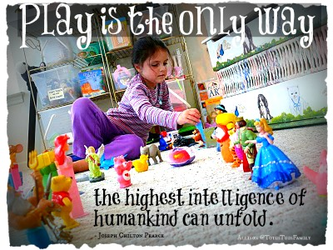

This Capstone project is a collection of guided-play learning experiences that align with the kindergarten math standards and the Eureka Math Curriculum for kindergarten. These are activities that allow the students to practice the skills they are learning while engaging in physical, cognitive, social, and emotional development. I have included the Common Core Standards for kindergarten math. The main body of this document is organized to reflect the Modules of the Eureka Math Curriculum that the play learning experiences are based on.
These activities, done in small groups, can be carried out using materials that are easily accessed online or that I already had in my classroom that the children were naturally drawn to – the dramatic play area, blocks, playdough, games, cars, and manipulatives. Although they were put together based on the kindergarten curriculum, all the activities can be adjusted to be appropriate for other ages. I use some of them in the preschool classroom I am currently working in.
This past year has made us all appreciate the value of face-to-face contact. No one needs that more than children. Play is a vital and important way for children to learn about the world and how to successfully navigate it. Through play, children learn to use their imagination and increase creativity. They develop better language skills. Through play, children learn social interaction skills and learn to regulate their emotions. Play helps children build confidence in themselves and their ability to form relationships with others. It can also help reinforce the academic lessons they are learning.
My research question, “Can play be incorporated into the kindergarten schedule without interrupting the rigor of instructional curriculum?” is without a doubt answered. It can and it should. Using play experiences in the classroom can help children learn the relevance of the skills they are practicing. It can also help a teacher, who struggles to like math, learn to find the joy in teaching it!
This is dedicated to the teachers that helped shape me as a student, and the students who helped shape me as a teacher. I find joy in your joy of learning.

“We don’t stop playing because we grow old. We grow old because we stop playing.” – George Bernard Shaw

Kindergarten Math Common Core Standards – Corestandards.org/math/content/k/introduction/
In Kindergarten, instructional time should focus on two critical areas: (1) representing and comparing whole numbers, initially with sets of objects; (2) describing shapes and space. More learning time in Kindergarten should be devoted to number than to other topics.
- Students use numbers, including written numerals, to represent quantities and to solve quantitative problems, such as counting objects in a set; counting out a given number of objects; comparing sets or numerals; and modeling simple joining and separating situations with sets of objects, or eventually with equations such as 5 + 2 = 7 and 7 – 2 = 5. (Kindergarten students should see addition and subtraction equations, and student writing of equations in kindergarten is encouraged, but it is not required.) Students choose, combine, and apply effective strategies for answering quantitative questions, including quickly recognizing the cardinalities of small sets of objects, counting and producing sets of given sizes, counting the number of objects in combined sets, or counting the number of objects that remain in a set after some are taken away.
- Students describe their physical world using geometric ideas (e.g., shape, orientation, spatial relations) and vocabulary. They identify, name, and describe basic two-dimensional shapes, such as squares, triangles, circles, rectangles, and hexagons, presented in a variety of ways (e.g., with different sizes and orientations), as well as three-dimensional shapes such as cubes, cones, cylinders, and spheres. They use basic shapes and spatial reasoning to model objects in their environment and to construct more complex shapes.

Grade K Overview

Counting and Cardinality
- Know number names and the count sequence.
- Count to tell the number of objects.
- Compare numbers.

Operations and Algebraic Thinking
- Understand addition as putting together and adding to, and understand subtraction as taking apart and taking from.

Number and Operations in Base Ten
- Work with numbers 11-19 to gain foundations for place value.

Measurement and Data
- Describe and compare measurable attributes.
- Classify objects and count the number of objects in each category

Geometry
- Identify and describe shapes.
- Analyze, compare, create, and compose shapes.

Mathematical Practices
- Make sense of problems and persevere in solving them.
- Reason abstractly and quantitatively.
- Construct viable arguments and critique the reasoning of others.
- Model with mathematics.
- Use appropriate tools strategically.
- Attend to precision.
- Look for and make use of structure.
- Look for and express regularity in repeated reasoning.

Module 1 – Numbers to 10

- Attributes of two related objects

Play experiences:
Memory Game with pictures/visual patterns
Potato Head Matching-assemble potato heads with matching pieces
Dramatic Play
Set the table using dishes/utensils that are the same or not exactly the same
Describe foods/objects that are the same/different
Match pairs of patterned socks on clothesline

Candy Land Game

- Classify to Make Categories and Count

Dramatic Play
Sort items in kitchen (food, utensils, etc.)

Sort students – allow students to decide how to be sorted (by hair, eyes, clothing, etc.)
Sorting stations around the room: shapes, art materials, transportation, kitchen items, mini erasers, Legos, magnets, bears, pom poms, etc.
Sort subitizing pictures (numbers 2, 3, and 4)

- Numbers to 5 in Different Configurations, Math Drawings, and Expressions

Put numbered Legos together in order
Dramatic Play
Pretend store – Use play money to “buy” items labeled 1-5
Number Memory – Use Uno/playing cards
Match Dominos
Draw 2 number cards (Uno or playing cards) compare numbers using cubes, bears, dominoes, etc. (use balance scale to determine more/less)
Playdough number mats
Subitizing puzzles
Sort dominos by number of dots

- The Concept of Zero and working with numbers 1-5
- Working with Numbers with numbers 6-8 in Different Configurations
- Working with Numbers 9-10 in Different Configurations

Flip and Compare – Flip two cards, build tower with cubes or Legos, determine more than/less than
Make numbers with playdough
Stamp in playdough with Legos
Patterning with Legos
Build towers on Uno cards
Toss beanbag onto paper number, do that many gross motor activities (i.e. jump, hop, clap, etc.)
Dramatic Play – Set up a restaurant; make menu with dollar amount of $1 - $5.
Set up a Post Office; sort mail by number
Park play cars on numbered parking spaces (draw parking spaces on paper)
Grab and count – pick up handful of Legos, count, compare with partner
I Have/Who Has Number games
Play Hopscotch
Roll and Count – www.thestemlaboratory.com

- One More with Numbers 0-10
- One Less with Numbers 0-10

Dramatic Play area – encourage students to make change for “purchases”
Roll Dice, show one more or one less with mini erasers
Put dominos in order of how many dots
One more/One Less mat – Roll dice, use bears, cubes, erasers, etc. to show how many. Tell partner one more is, one less is.
Find the Difference Face Off game - www.frugalfun4boys.com
Ladybug One More & One Less - www.fantasticfunandlearning.com

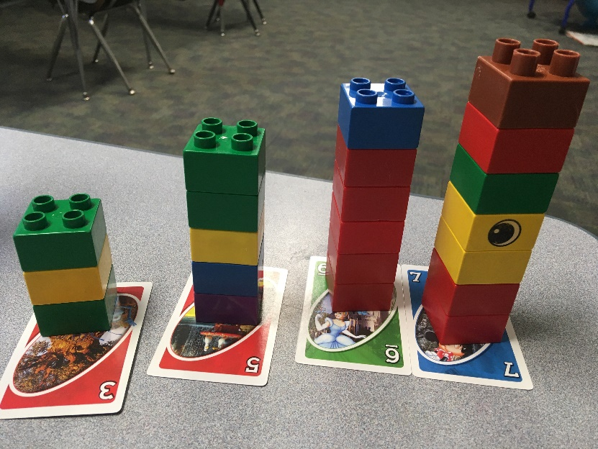

Module 2 – Two Dimensional and Three-Dimensional Shapes

- Two-Dimensional Flat Shapes

Sort shapes using pattern blocks
Students sort shapes on Venn diagram made with hula hoops
Shape bingo
Play Qwirkle game
Make shapes with playdough and shape cards https://homeschoolcreations.com
Students work together to make shapes with bodies
Shapes game – www.fantasticfunandlearning.com
Roll a Shape game – www.themeasuredmom.com
The Shape Game – www.themeasuredmom.com
Shape Bingo – www.PreschoolMom.com

- Three-Dimensional Solid Shapes

Use Magnatiles to build shapes
3-D Shapes Memory Game
Construct Shapes using playdough and popsicle sticks
3-D Shape Matching Puzzles – www.fantasticfunandlearning.com

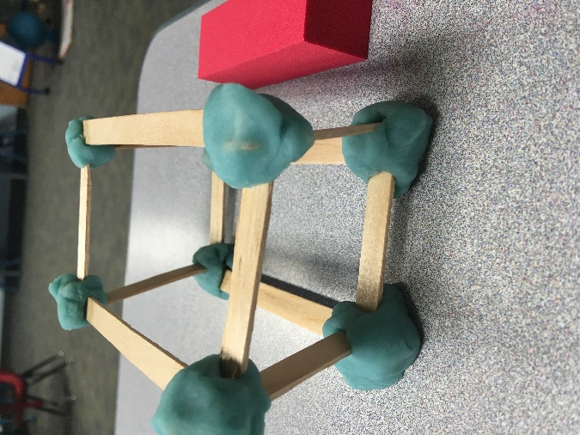

Module 3 – Comparison of Length and Height

- Comparison of length and height
- Comparison of length and height of linking cube sticks within 10

Use manipulatives to measure/compare length and height
Cubes
Links
Blocks
Tape measure
Cut string and compare lengths
Make strings of playdough and compare, measure with ruler
Draw numbers or playing cards, build towers with cubes or pegs, compare heights
Stack blocks, compare heights
Build towers with Magna-tiles
Roll dice, add cubes to towers
Students measure each other with wooden blocks or other objects (i.e. shoes, hands, cars, etc.)
Back to School Measurement - www.Unitedteaching.com
Play “1,2,3, break” – Two students build towers of 10 cubes. Each puts the tower behind their back. Count to 3 and break the tower. Students then compare their towers (longer/shorter.)

Measure food in the Dramatic Play area using linking cubes
Use linking cubes to measure names
Use objects (tape measure, linking cubes, blocks, etc.) to measure furniture in the Dramatic Play area

- Comparison of weight

Weigh kitchen play food with balance scale
Weigh playdough with balance scale
Game: Don’t Spill the Beans
Weigh classroom objects with balance scale (blocks, stuffed animals, manipulatives, art supplies, etc.)
Draw number card, compare weight of two items of that amount (i.e. two bears vs. two Legos)
Weight challenge – Put piece of playdough on one side of the balance scale. Challenge partner to match weight with objects – www.thestemlaboratory.com

- Comparison of Volume

Have different sized containers in the water table.
Have students guess how many objects are in a container
Put rice, beans, or sand in the sensory table with measuring cups
Have students guess how many cups it would take to fill a container using different sized measuring cups or drinking cups
Use measuring cups in the Dramatic Play area to make “recipes” using beans or flour

- Are there enough?

Fill in shapes on paper (or floor) with objects (i.e., bears, cubes, blocks, cars, food, etc.)
Fill in large shape on the floor with students or shoes
Fill in plates with cubes, bears, etc. in the Dramatic Play area
Using play cars, compare number of cars to number of parking spaces
Play Musical Chairs
In Dramatic Play, compare number of plates, utensils, etc. to amount of food to see if there is enough for each plate.
Play Hi-Ho Cherry-O
Play “1,2,3, Break” and compare more, less, the same
Draw a number card and build with blocks or Legos using that amount
Make sets with shapes

- Comparison of sets within 10

Compare sets of different objects (bears, blocks, food from play kitchen, etc.) to determine which set has more/less.
As partners, one student draws a set of shapes. The partner draws a set that has 1 more or 1 less.
Play “1, 2, 3, Break.” Partners identify which has more, less, fewer, same.

- Comparison of numerals

Two students flip Uno/playing cards, determine which number is more/less.
Play the game, “Chutes and Ladders”
Play the game, “Hi Ho Cherry-O”
Draw a number card and use a balance scale to weigh and compare different amounts of objects
Two students take a handful of objects (i.e., bears) and compare amounts using more/less than, same
Build train tracks and compare number of track pieces, train cars

- Clarification of Measurable Attributes

Use eyedroppers to drop colored water into shapes
Have measuring cups, containers of different sizes in water/sand table
Use measuring cups/spoons with playdough
Make different sculptures from playdough of the same weight
Build with wood blocks from pictures of local landmarks, measure with cubes
Measure volume of 3-d shapes
Measure food containers in Dramatic play area (i.e., cereal boxes)
Use common household containers in the water/sand table (i.e., milk, orange juice, or butter container)
Use a balance scale in the water table with plastic eggs
Use measuring cups in the water table with rocks

Module 4 – Number pairs, addition, and subtraction to 10

- Compositions and decompositions of 2, 3, 4, and 5

Draw number card, use Legos to represent numbers, add or subtract
Playdough subtraction – www.thekindergartensmorgasboard.com
String beads on pipe cleaners to represent addition
Roll dice, build with cubes or Legos to represent addition
Roll dice, build number with different colored playdough
Play “1, 2, 3, break”
Use hula hoops to represent number bonds, use stuffed animals to represent numbers
Use playdough in number bonds
Add dots on dominos to fill in number bonds with playdough
Use plates from Dramatic play to represent number bonds, fill with food
Play the “Lego Game” – www.Playdoughtoplato.com
Addition & Subtraction Fluency within 5 game - www.123homeschoolforme.com

- Decomposition of 6, 7, and 8 into number pairs

Use construction paper parking lots to represent number bonds, park cars
Build with blocks, Legos, bears, etc. in number bonds
Use plates from Dramatic play to represent number bonds
Stamp playdough with Legos
Stamp playdough with dinosaur feet
Use cubes to represent dots on dominos
Put playdough balls in number bonds

- Addition with totals to 6, 7, and 8

Use hula hoops and food to represent number bonds
Use Legos, math cubes, bears, playdough in number bonds
Play Chutes and Ladders game
Roll and Add game – https://rainydaymum.co.uk
Play Memory

- Subtraction from numbers to 8

Play Hi-Ho Cherry-O game
Bowling
Subtraction Smash with playdough – www.recipeforteaching.com
Parking lot number bonds/cars – make numbered parking lots for number bonds
Tally food in the Dramatic play area
Lego tower subtraction Race with dice – instead of building a Lego tower roll by roll, start with 10 and take Legos off
Pretend play store inventory

- Decomposition of 9 and 10 into number pairs

Bowling (label pins with numbers)
Parking lot number bonds/cars
Serve beans (add and subtract) in Dramatic play
Play “1, 2, 3, break”
Make arrays with cars, parking lot

- Addition with totals of 9 or 10

Roll dice, add Legos, pegs, blocks, etc. to 9 or 10
Flip Uno/playing cards, add to 9 or 10
Dramatic Play - Pretend play shopping
Use hula hoops to make number bonds, use students to represent numbers
What can you build using 9 or 10 Legos
Roll and Add game - https://rainydaymum.co.uk

- Subtraction from 9 and 10

Bowling
Roll dice, subtract play cars from parking lot
Play “1, 2, 3, break”
Dramatic Play - Use play money to “shop,” make change
Play Hi Ho Cherry-O
Flip Uno/playing card. Subtract from 9 or 10
Subtraction Facts Game cards - https://rainydaymum.co.uk

- Patterning with adding 0 and 1 making 10

Roll dice, race to 10 on number path
Draw card, name number that is one more
Draw card or roll dice, put objects on 10-frame or number path, compare
Trace hands, roll dice to get to 10

Hi Ho Cherry-O
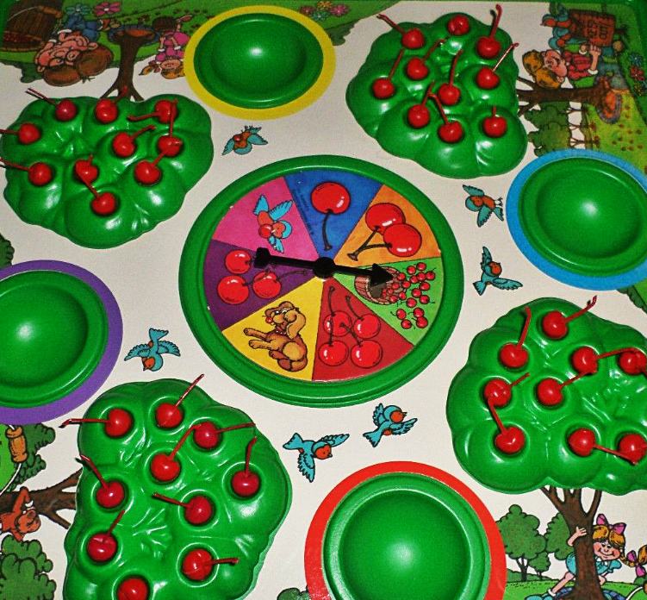

Module 5 – Numbers 10-20 and Counting to 100

- Count 10 ones and some ones

Play teen number Bingo – www.mrsbsbeehive.com
Draw teen number card, build with that many Legos/blocks
Assemble picture puzzles labeled with teen numbers
Draw 2 teen numbers, weigh that many beans, bears, etc. on balance scale

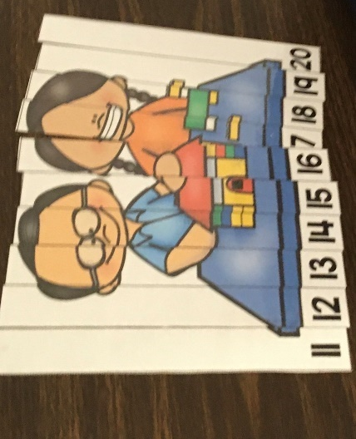

- Compose numbers 11-20 from 10 ones and some ones; Represent and write teen numbers

Roll and Race game – www.thisreadingmama.com
Dramatic Play - Play store – label $10 on some food, ones on others
Play Chutes and Ladders
Flip Uno cards, add to 10
Assemble Legos marked with numbers and/or dots
Flip number card, build with cubes
Draw number card, set up Dominos
Number bond parking lots
Go Fish - www.teacherspayteachers.com/store/creative-math-nerd
Bubble Bonds - www.Thestemlaboratory.com
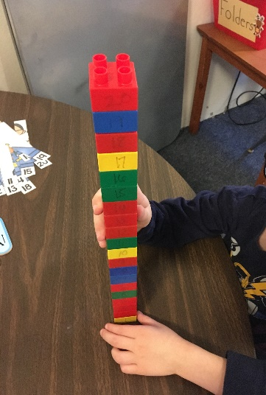

- Decompose numbers 11-20 and count to answer “How many?” questions in varied configurations

Assemble numbered picture puzzles
Spin & Cover game - www.teacherspayteachers.com/store/Elaine-Maggard
Flip card, add to 10, build with Legos, cubes, blocks
Go Fish card game
Build with numbered Legos
Memory game with numbers, 10-frames
Dramatic Play - Label plates and food to sort in Dramatic play area

- Extend the say ten and regular count sequence to 100

Play Chutes and Ladders
Roll die and Cover 100 chart with pennies
Counting by 10’s with numbered cars, Legos, blocks, etc.
Hopscotch by 10’s
Playdough, make 100 balls

- Represent and apply compositions and decompositions of teen numbers

Teen number puzzles – www.teacherspayteachers.com
Spin and Cover game – www.teacherspayteachers.com/store/Elaine-Maggard
Draw a teen number card, count, build with that many Legos
Dramatic Play - Sort food in dramatic play by labeled teen numbers
Roll and Race to 20 on number lines

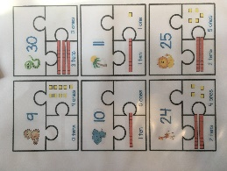

Module 6 - Analyzing, Comparing, and Composing Shapes

- Building and drawing flat and solid shapes

Make shape pictures with paper shapes or colored toothpicks
Build shapes with Magna-tiles
Build shapes using playdough and toothpicks or popsicle sticks
Make shapes with playdough on shape mats
Build with wooden blocks

- Composing and decomposing shapes

Create pictures using pattern blocks
Combine pattern blocks to create new shapes using pattern cards
Press pattern blocks into playdough to make shapes
Construct shapes using pattern blocks
Roll and Cover Game
Pattern Block Logic Puzzles

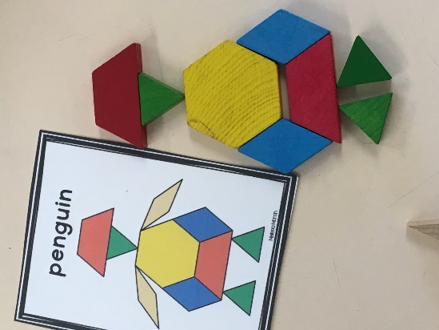

Resources

Lego Addition to 5 – www.PlaydoughtoPlato.com

Counting to 6 – www.Thestemlaboratory.com

Back to School Measurement – www.Unitedteaching.com

Bubble Bond Numbers – www.Thestemlaboratory.com

Playdough Mats (Numbers 0-10) –www.Homeschoolcreations.com

Ladybug One More & One Less – www.fantasticfunandlearning.com

Shape puzzle cards –www.fantasticfunandlearning.com

Spin and Cover 3D Shapes – www.lifeovercs.com

Shapes Game – www.fantasticfunandlearning.com

Marshmallow Shapes – www.lifeovercs.com

The Shape Game – www.themeasuredmom.com

Roll a Shape – www.themeasuredmom.com
Shape Bingo – www.PreschoolMom.com

Weight challenges – www.thestemlaboratory.com

Addition and Subtraction fluency within 5 – www.123homeschoolforme.com

Playdough subtraction – www.thekindergartensmorgasbord.com

2D Shapes Playdough Mats – www.Misskindergarten.com

Find the Difference Face Off! – www.frugalfun4boys.com

Subtraction Smash – www.recipeforteaching.com

Counting Apples – https://rainydaymum.co.uk

Teen Number Go Fish – www.teacherspayteachers.com/store/creative-math-nerd

Subtraction Facts Game Cards – https://rainydaymum.co.uk

Roll and Add – https://rainydaymum.co.uk

Roll & Race Addition & Subtraction Games – www.thisreadingmama.com

Build and Write – www.akteacherlife.com

Teen Number Spin & Cover Board Game – www.teacherspayteachers.com/store/Elaine-Maggard

Decomposing Teen Numbers puzzle –https/www.teacherspayteachers.com/Product/FREE-Decomposing-Teen-Numbers-Place-Value-Puzzles-for-Math-Centers-3295098?st=c5279703efc5c28485bbbeeec39509ad

